NBA Quizzer

Aaron Huff & ISAAC BRIMNER

NBA Quizzer is an NBA knowledge game with a query search built in to help find answers. This game utilizes NBA Statistics from the 2020 season but can be regularly updated once games begin for 2021 or can be set to reference older data sets. This game has two functions 1) To create a quiz & 2) to take quizzes that have been created by other users. As you take a quiz you will be able to submit answers individually to determine if you answered correctly.

Websites like sporcle & quizcenter offer a variety of NBA quizzes with different themes, however they do not offer the ability to create quizzes on the fly or have a user database available for you to save your quizzes and have other users take them. These games also have set quizzes with fixed answers and do not offer a player database to search for answers based on a specific query.

When writing this game, we utilized a mixture of Python & Microsoft’s SQL Server product. To manage the networking aspect, we are utilizing Azure to host the server and database online. Currently access to the database is limited to whitelisted IP addresses. To offer limited use without a whitelisted IP; users can opt to not log in to an account and continue as a guest. A guest user has all the access to the program as an authorized user, but they cannot save their own quizzes to a profile. We utilized the PyOBDC library to inject connection information for our server directly into the Python code. (Lines 10-18 current_build.py) OBDC is an API for database connectivity that allows us to connect to our SQL server. Once inside the program the SQL Database references a table with every active NBA player statistic on it and uses that to create a searchable database off a variety of options. Alongside the statistical database the python program creates a new input to the user table every time an account is made as well as a table for tables created. All the database storage is done using an Azure Blob Storage – this Microsoft specific object storage solution allows us to save a multitude of data types on the Server and access it.

Besides PyOBDC we also utilized the Beautiful Soup library to scrape data from a websites HTML code and pull it into a CSV filed saved in our blob storage. This file is then bulk added into a table for use by the database. We would like to add more functionality to this project; ultimately, we would like to be able to whitelist an IP as a user accesses the application and find a more secure way of storing user login information. We would also like to be able to have the HTML scraped data be immediately added into the database and on a schedule, so the information was updated consistently. Much of this functionality requires some additional Azure features that we are not currently paying for but could once needed. During the development process we ran into a variety of roadblocks, finding a graphic library that suited our needs was not difficult as we wanted to go with a 90s feel, however the library that we chose does not have global variables that can be set for color values or positions, so we had to manually add color commands for each additional clicker or entry box added. We also had some initial issues getting the information in the database to communicate how we wanted with the program and formatting inputted data from the program to save to the database in the correct format so it could be retrieved later and saved for a specific user.

User Guide

Building from CMD –

Necessary Dependencies:

* Python 3 (https://www.python.org/downloads/)
* PyODBC (pip install pyodbc)
* Pandas (pip install pandas)
* PandasGUI (pip install pandasgui)
* BeautifulSoup (pip install beautifulsoup)
* Tkinter (pip install tkinter)
* PIL (pip install pillow)
* Time (pip install time)
* Numpy (pip install numpy)

Login Window:

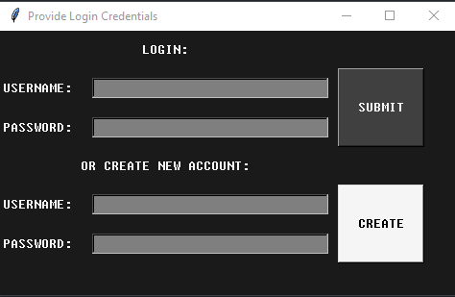

When accessing the User Screen, you have 3 options:

1. Login with an existing account
2. Create a new account
3. Select the (x) and the program will load a guest user profile

Root Display:

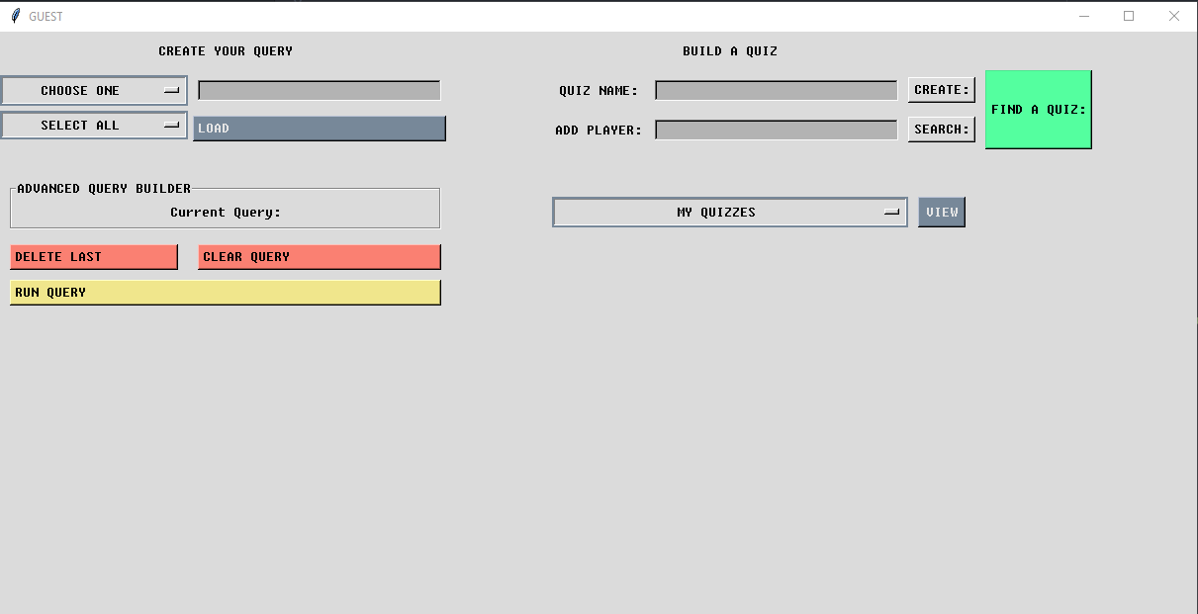

When accessing the Root Display, you have 3 major Options:

1. Create Your Query
2. Build a Quiz
3. Find A Quiz

Create Your Query:

This powerful tool allows users to search a database of all current NBA players based on a massive set of filters. First, you can select a filter like “Age” and set an option, you can then leave the second option as “Select All” to see all known statistics for every player that age or limit it further by choosing an additional option. Once your query options are prepared you will select the “Load” option to prep the query and then select “Run Query”. (We are currently getting a QTWebEngineProcess error when loading queries with PandasGUI, but it still loads properly). Here is an example query for 26-year-old players sorted by Points per game.

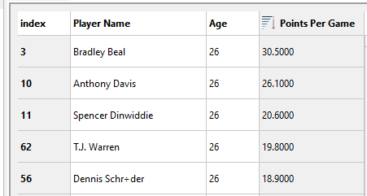

Build a Quiz:  
 Build a Quiz allows a user to create a quiz of players and add hints to solving the players identity. When creating a quiz you will need to pick a name for it, and then press “Create:”. After pressing create you will be given the option of adding a description to the quiz to help narrow down search options. Once you have determined your description press “Submit” and then exit out of the window.

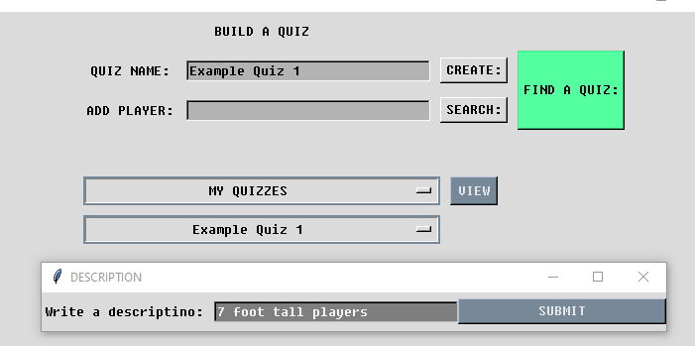Now you will be able to search for a player to add to your quiz, if you do not know who you want to add you can run a query for the description to find players that meet your criteria.

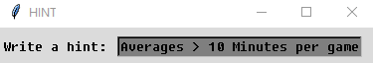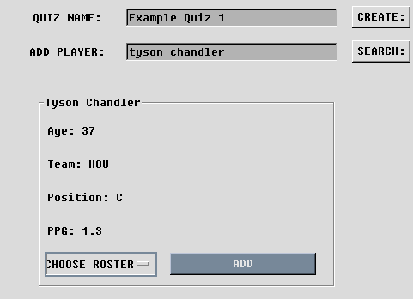Below you can see where I searched for Tyson Chandler, a 7’1 player for the Houston Rockets. After clicking search an information box appears with a dropdown menu allowing you to select a roster to add him too. If you are signed in with an account, you can add to any of the quizzes you currently have made. Once you are ready you can hit “Add” and a hint box will appear. This hint is meant to assist the contestant in finding the player you are referencing. For Tyson we will say “Averages > 10 minutes per game, and is 37 years old”

Works Cited

Richardson, Leonard. “Beautiful Soup Documentation¶.” *Beautiful Soup Documentation - Beautiful Soup 4.9.0 Documentation*, 2004, *[www.crummy.com/software/BeautifulSoup/bs4/doc/](http://www.crummy.com/software/BeautifulSoup/bs4/doc/)*.

Microsoft. “SQL Server 2019.” *Microsoft*, 2019, www.microsoft.com/en-us/sql-server/sql-server-2019.

Python. “Pyodbc.” *PyPI*, 2020, pypi.org/project/pyodbc/.

Microsoft. “Download SQL Server Management Studio (SSMS) - SQL Server Management Studio (SSMS).” SQL Server Management Studio (SSMS) | Microsoft Docs, 27 Oct. 2020, [docs.microsoft.com/en-us/sql/ssms/download-sql-server-management-studio-ssms?view=sql-server-ver15](http://docs.microsoft.com/en-us/sql/ssms/download-sql-server-management-studio-ssms?view=sql-server-ver15).